WEEK-3 PROJECT REPORT

TELECOM DATA GOVERNANCE & SECURITY

Internship Domain:
Telecom Data Governance & Security
Duration:
6 Weeks
Submitted by:
DUDATI RASIKA
Week:
Week3 - Telecom Data Access and Security Protocols Design

1.Introduction
Telecommunication organizations generate and process a large amount of data through their daily operations. This includes customer information, service details, billing information, network information, usage records and operational data. As telecom organizations depend heavily on digital systems, protecting this information is an important part of data governance.
Data access and security protocols are used to ensure that information is accessed only by authorized users. They also help protect data from unauthorized modification, accidental loss, misuse and security incidents.
The purpose of this task is to design a practical data access and security framework for a telecom environment. The framework focuses on authentication, authorization, role-based access control, data protection, access monitoring, audit logging and incident response.
The proposed security framework is also related to the Telecom Data Governance and Security project developed using Flask. The project provides a practical environment for implementing data governance, data quality and security concepts.
2.Objectives
The main objective of this task is to design a secure and controlled mechanism for accessing telecom data.
The major objectives are:
- To understand security challenges related to telecom data.
- To design a secure authentication mechanism.
- To control access according to user roles.
- To prevent unauthorized access to sensitive information.
- To implement the principle of least privilege.
- To monitor important user activities.
- To maintain audit logs.
- To define an incident response procedure.
- To connect security concepts with the developed Flask project.
- To improve the overall security and accountability of telecom data.

3.Scope of the Security Framework
The proposed security framework covers the major areas required for secure telecom data management.
The scope includes:
- User authentication
- User authorization
- Role-based access control
- Data access management
- Security monitoring
- Audit logging
- Data protection
- Incident response
- Access review
- Security reporting
4.Telecom Data and Its Security Requirements
Telecom organizations manage different types of information during their operations.
Major types of telecom data
Data Type | Example
Customer Data | Customer details and subscriber information
Service Data | Details of subscribed services
Billing Data | Billing and payment-related information
Network Data | Network and technical information
Usage Data | Service usage records
Operational Data | Business and operational information
Security Data | Login and access information
4.1 Confidentiality
Confidentiality means that information should be accessible only to authorized users.
For example, a user who does not have permission to access sensitive data should not be able to view it.
4.2 Integrity
Integrity ensures that information remains accurate and is not changed without proper authorization.
4.3 Availability
Availability ensures that authorized users can access required information when it is needed.
4.4 Accountability
Accountability means that important activities performed by users can be recorded and traced.
5.Authentication
Authentication is the process of verifying the identity of a user before providing access to the system.
In the proposed application, the user first enters login credentials. The system verifies the credentials and then provides access if they are valid.
Authentication process
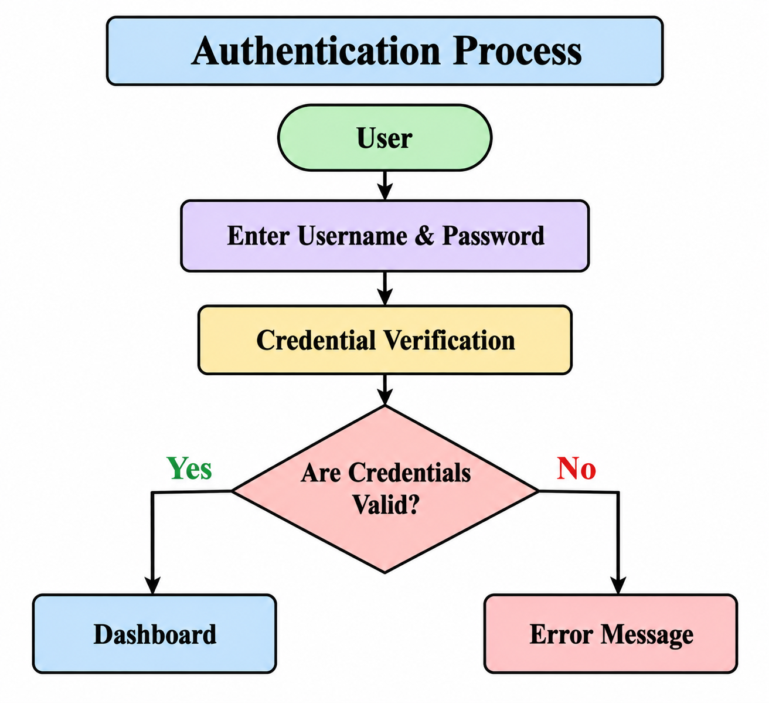
Important authentication practices
- Use strong passwords.
- Do not store passwords as plain text.
- Validate login credentials.
- Control user sessions.
- Record important login activities.
- Restrict repeated unauthorized attempts.
6.Authorization
Authorization determines what an authenticated user is allowed to do.
Authentication and authorization are different.
Authentication:
"Who is the user?"
Authorization:
"What is the user allowed to access?"
For example, an administrator may be allowed to manage users, while a data analyst may only be allowed to view and analyze data.
Authorization process
User Login
↓
Authentication
↓
Identify User Role
↓
Check Permissions
↓
Allow / Deny Access
7.Role-Based Access Control
Role-Based Access Control, or RBAC, is a method of controlling access based on the user's assigned role.
Instead of assigning permissions separately to every user, permissions are associated with roles.
Proposed user roles
Role | Access
Administrator | Full system access
Data Analyst | Data quality and analysis
Security Officer | Security and audit information
Viewer | Read-only access
RBAC structure
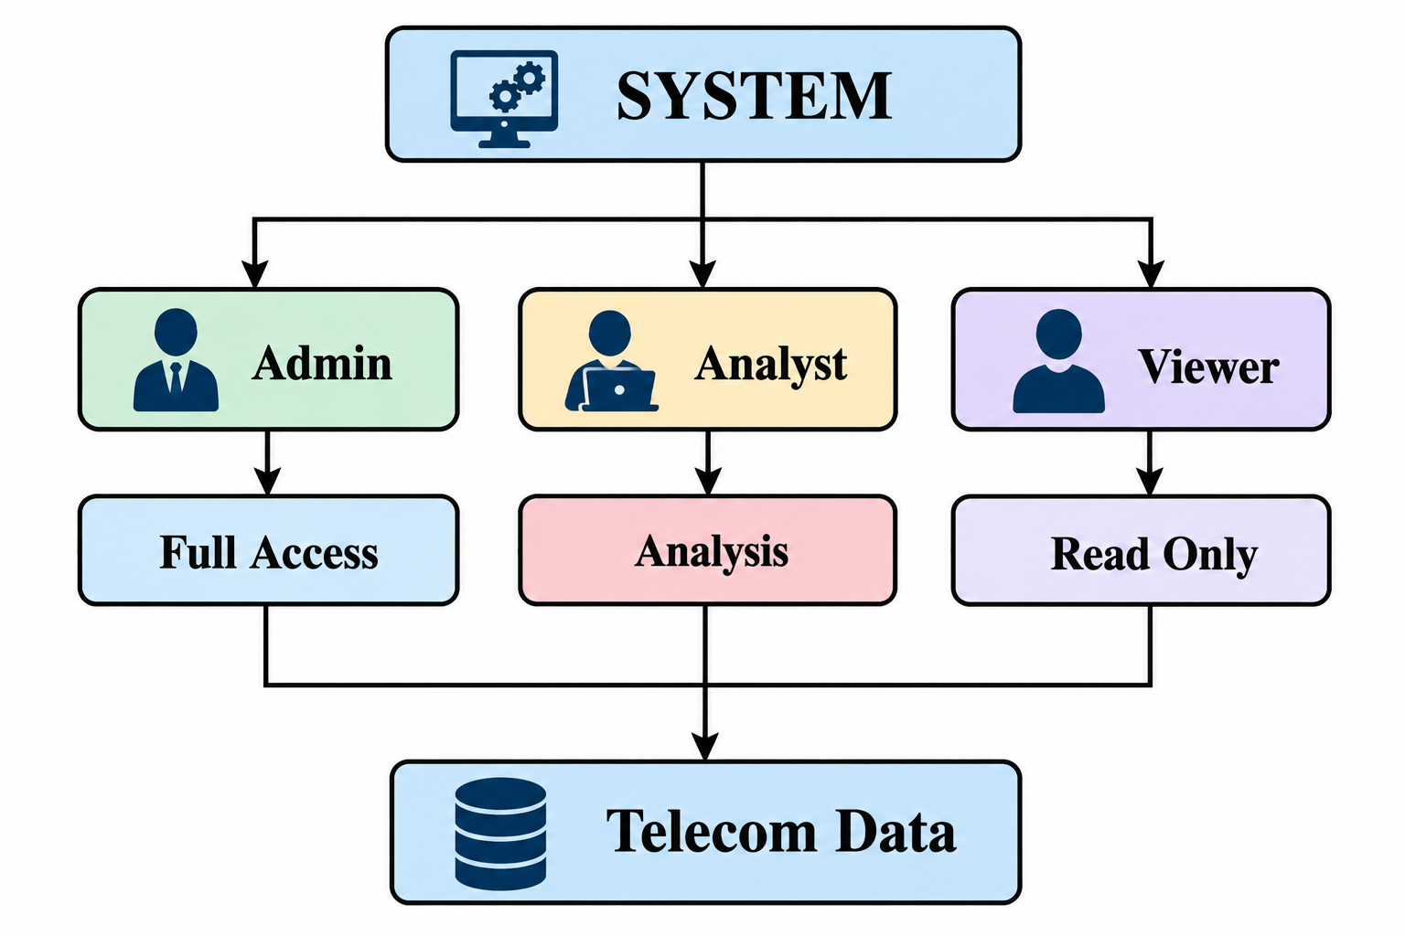
7.1 Administrator
The administrator can have access to:
- User management
- Data management
- Security settings
- Reports
- Dashboard
- System configuration
7.2 Data Analyst
The analyst can have access to:
- Data analysis
- Data quality
- Dataset information
- Analytical reports
7.3 Security Officer
The security officer can have access to:
- Security information
- Audit logs
- Access monitoring
- Security reports
7.4 Viewer
The viewer can have:
- Dashboard access
- Read-only report access
8. Principle of Least Privilege
The principle of least privilege means that users should receive only the permissions required to perform their assigned responsibilities.
For example, a data analyst may need to analyze telecom data but does not need permission to manage user accounts.

Example
Role | Required Access | Restricted Access
Administrator | All modules | —
Data Analyst | Analysis, Data Quality | User Management
Security Officer | Security, Audit | Data Modification
Viewer | Dashboard | Configuration

Benefits
- Reduces unnecessary permissions.
- Limits unauthorized activities.
- Reduces accidental modifications.
- Improves security.
- Makes access management easier.
9. Common Security Threats
Telecom data systems can face several security threats. Understanding these threats is necessary for designing appropriate security controls.
9.1 Unauthorized Access
Unauthorized access occurs when a person accesses information without the required permission.
Possible causes:
- Weak passwords
- Stolen credentials
- Incorrect permissions
- Shared accounts
- Poor access management
Preventive measures:
- Strong authentication
- Role-based access
- Access monitoring
- Regular permission reviews
- Audit logging

9.2 Data Leakage
Data leakage occurs when sensitive information is exposed to unauthorized individuals.
It can occur because of:
- Incorrect permissions
- Accidental sharing
- Unauthorized downloads
- Insecure data transfer
Controls
- Access restrictions
- Encryption
- Monitoring
- Data classification
- User awareness
9.3 Insider Threat
An insider threat may occur when an authorized user intentionally or accidentally misuses their permissions.
Controls include:
- Least-privilege access
- Activity monitoring
- Audit logging
- Periodic access review
- Separation of responsibilities
9.4 Data Modification
Unauthorized modification can affect the accuracy and reliability of telecom data.
Controls include:
- Authorization
- Input validation
- Change tracking
- Audit logs
9.5 Malware and Phishing
Malicious software and phishing attempts may be used to obtain user credentials or gain unauthorized access to systems.
Possible controls include:
- Security awareness
- Access control
- Monitoring
- Secure authentication
- Regular security updates
10. Multi-Layer Security Approach
A single security control is not sufficient to protect telecom information. Therefore, the proposed framework follows a multi-layer security approach.
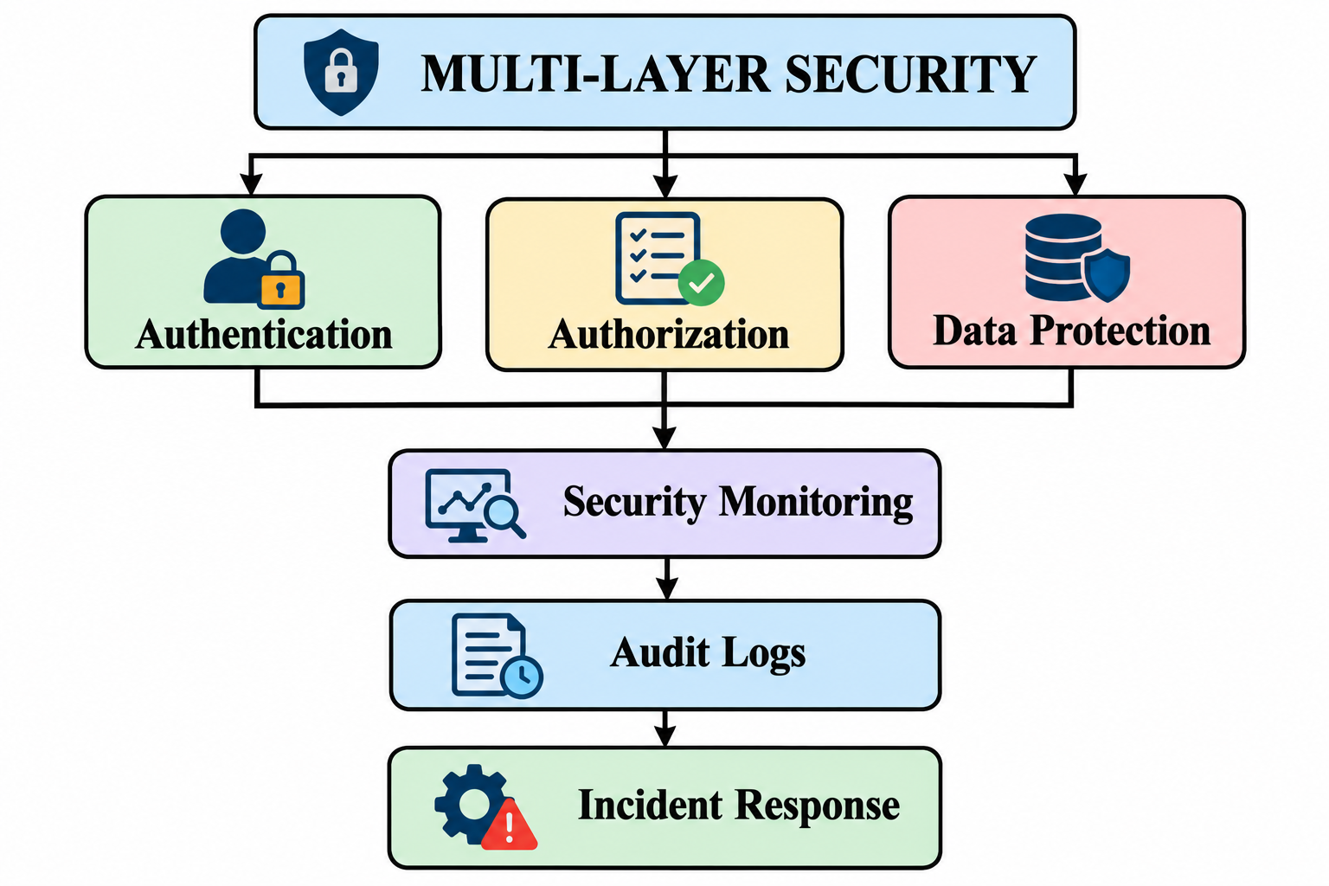
Authentication
Verifies the identity of users.
Authorization
Determines what the user is allowed to access.
Data Protection
Protects important information from unauthorized access.
Monitoring
Records and observes important activities.
Auditing
Maintains records that can be reviewed when required.
Incident Response
Provides a structured process for handling security incidents.
11. User Access Management
User access should be managed throughout the complete period in which a user has access to the system.
Access management process
Access Request
↓
Approval
↓
Access Provisioning
↓
User Activity
↓
Monitoring
↓
Periodic Review
↓
Modify / Continue / Remove
Access Request
The user requests access according to their job requirements.
Approval
The request is reviewed by an authorized person.
Access Provisioning
Required permissions are assigned to the user.
Monitoring
User activities are monitored through system records.
Periodic Review
User permissions are reviewed regularly.
Access Removal
When access is no longer required, permissions should be removed.
This process helps prevent users from keeping unnecessary permissions.
12. Security Monitoring
Security monitoring involves observing system activities to identify unusual or unauthorized actions.
Activities that can be monitored:
- Successful login
- Failed login
- Unauthorized access attempt
- User permission changes
- Data access
- Administrative actions
- Security events
Monitoring process
User Activity
↓
System Monitoring
↓
Activity Recorded
↓
Suspicious Activity?
/ \
Yes No
↓ ↓
Alert Continue
13. Audit Logging
Audit logging is the process of recording important activities performed within the application.
An audit log can contain:
- Username
- Activity
- Date
- Time
- Access status
- Module accessed
Example audit log
User | Activity | Time | Status
Admin | Login | 10:00 AM | Successful
Analyst | Data Analysis | 10:15 AM | Successful
Viewer | Dashboard | 10:20 AM | Successful
User1 | Restricted Page | 10:25 AM | Denied

Benefits
- Provides accountability.
- Helps investigate security incidents.
- Records user activities.
- Helps identify suspicious behaviour.
- Supports security reviews.
14. Security Controls
The proposed framework uses different controls to protect telecom data.
Security Area | Control | Purpose
Authentication | Username and password | Verify identity
Authorization | RBAC | Control access
Data Protection | Encryption | Protect sensitive information
Monitoring | Activity monitoring | Identify unusual activity
Auditing | Audit logs | Record activities
Access Management | Permission review | Remove unnecessary access
Recovery | Backup | Support recovery
Incident Response | Response procedure | Handle incidents

15. Incident Response
Security incidents may occur even when preventive controls are implemented. Therefore, an organization should have a defined incident response process.
Incident response process
Detection
↓
Identification
↓
Containment
↓
Investigation
↓
Recovery
↓
Review
Detection
The organization identifies suspicious or unusual activity.
Identification
The incident is analyzed to understand what happened.
Containment
Steps are taken to limit the impact of the incident.
Investigation
Available logs and system information are reviewed.
Recovery
Normal operations are restored.
Review
The incident is documented and improvements are identified.

16. Security Framework for the Proposed Project
The security framework can be connected with the Flask-based project developed during the internship.
The current project contains components such as:
app.py
login.html
index.html
security.html
data_quality.html
data_analysis.py
telecom_data.csv
style.css
The proposed application flow is:
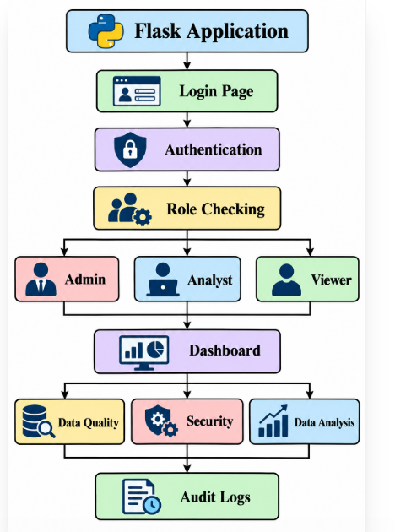

17. Expected Benefits
The proposed security framework provides several expected benefits.
Improved Data Protection
Security controls help protect sensitive information from unauthorized access.
Controlled Access
Users receive access according to their responsibilities.
Better Accountability
Audit logs provide information about important user activities.
Improved Monitoring
Security activities can be monitored systematically.
Better Incident Handling
A defined response procedure provides a structured method for handling security incidents.
Improved Data Governance
Security becomes an integrated part of the overall telecom data governance system.
18. Limitations
The proposed project is an internship-level implementation and therefore has some limitations.
- The number of user roles is limited.
- Advanced enterprise authentication is not included.
- Real-time security monitoring is limited.
- External security-system integration is not included.
- Advanced intrusion detection is outside the current scope.
- The application is developed in a controlled environment.
19. Future Scope
The project can be improved in the future by adding:
- Multi-factor authentication.
- Database-based user management.
- Advanced role management.
- Automated security alerts.
- Detailed audit dashboards.
- Encryption of sensitive fields.
- Real-time security monitoring.
- Automated security reports.
- Advanced incident management.
- Integration with enterprise security systems.
20. Conclusion
Data access and security are important components of telecom data governance. Telecom organizations need suitable controls to ensure that sensitive information is accessed only by authorized users.
This report presented a security framework based on authentication, authorization, role-based access control, least privilege, monitoring, audit logging and incident response.
The proposed framework also connects security concepts with the Flask-based Telecom Data Governance and Security project. This provides a practical way to demonstrate how security protocols can be incorporated into a data governance application.
Overall, the proposed approach provides a structured foundation for managing secure access to telecom data and can be further expanded with advanced authentication, monitoring and security-management features.
21. References
- Python Documentation.
- Flask Documentation.
- OWASP Application Security Resources.
- NIST Cybersecurity Framework.
- NIST Digital Identity Guidelines.
- ITU Telecommunication and Information Security Resources.
- Data Governance and Information Security concepts.

